**TI BYTE Simulation Exercise**

**Week 3 : RL Circuits**

* **Question 1:**

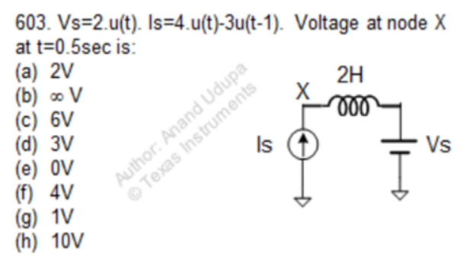

* **QUCS Circuit:**

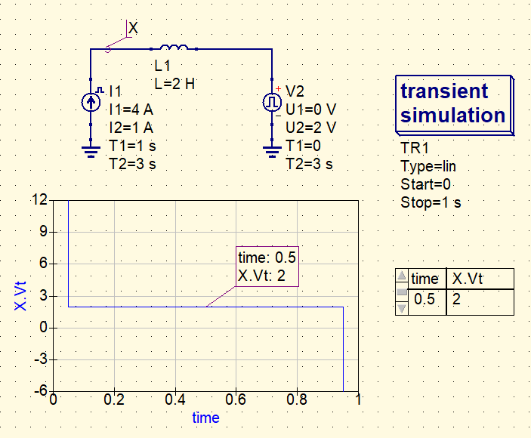

* **X is used to label the node and find the voltage at that node.**
* **Both the inductors have zero initial current through them.**
* **QUCS Result:**

**Therefore, from the simulation, we get our answer as:**

**Vx = 2V**

**Answer: (a)**

* **Conclusion:**
* **The final voltage at X can be found out using the Superposition Theorem.**
* **Upon considering the current source I1 only,**
$$I_{1}=4.u\left(t\right)-3.u(t-1)$$

$$I_{1}=\left\{\begin{aligned}4, 0≤t≤1 \\ 1, t>1 \end{aligned}\right.$$

* **Thus, voltage across the inductor due to the current source only,**
$$V_{L}=L\frac{dI}{dt}$$

$$I_{1}=\left\{\begin{aligned}δ\left(t\right), t=0 \\ -δ\left(t\right), t=1 \\ 0, elsewhere\end{aligned}\right.$$

* **Due to the voltage source V2, the voltage at X is 2V.**
* **Therefore, it can be said that, at t = 0.5s, the voltage at X is**

**Vx= VL + V2 = (0 + 2) V = 2V.**

* **Question 2:**

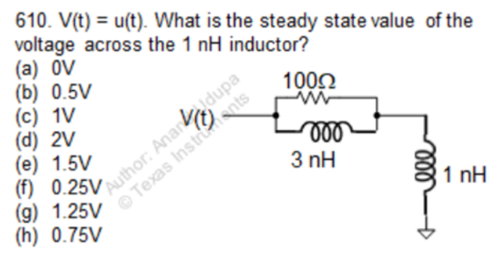

* + **QUCS Circuit:**

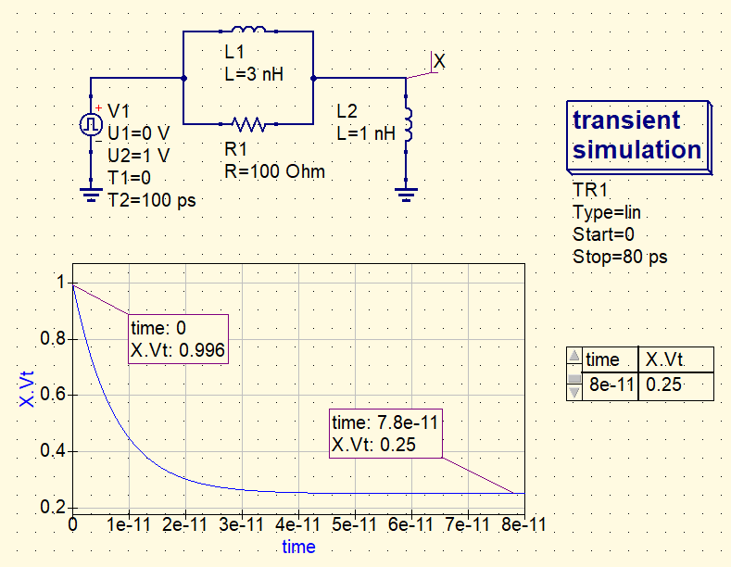

* **X is used to label the node at which the unknown voltage is to be determined.**
* **Both the inductors L1 and L2 are initially uncharged, i.e., having zero initial current in them.**
* **QUCS Result:**

**Therefore, from the simulation, we get our answer as:**

**Vx = 0.25V**

**Answer: (f)**

* **Conclusion:**
* **At t = 0, since both the inductors are uncharged, they have high impedances and behave as open circuits (o.c.).**
* **Thus, no current flows through them, or even through the R1.**
* **Therefore, the voltage at node X is**
$$V_{x}≈V_{1}=1V$$

* **Now, at t = ∞, both the inductors have reached steady state and have low impedance and behave as almost short circuits (s.c.).**
* **Since the current gets low impedance path through L1, the equivalent impedance becomes,**
$$L_{1}\left| \right| R_{1}≈L_{1}$$

* **Thus, the voltage at X at t = ∞ (), is just a voltage divider between L1 and L2,**
* **The final voltage at X = $\frac{L_{2}}{L_{1}+ L_{2}}$ = $\frac{1}{(1+3)}= \frac{1}{4}$ = 0.25 V**